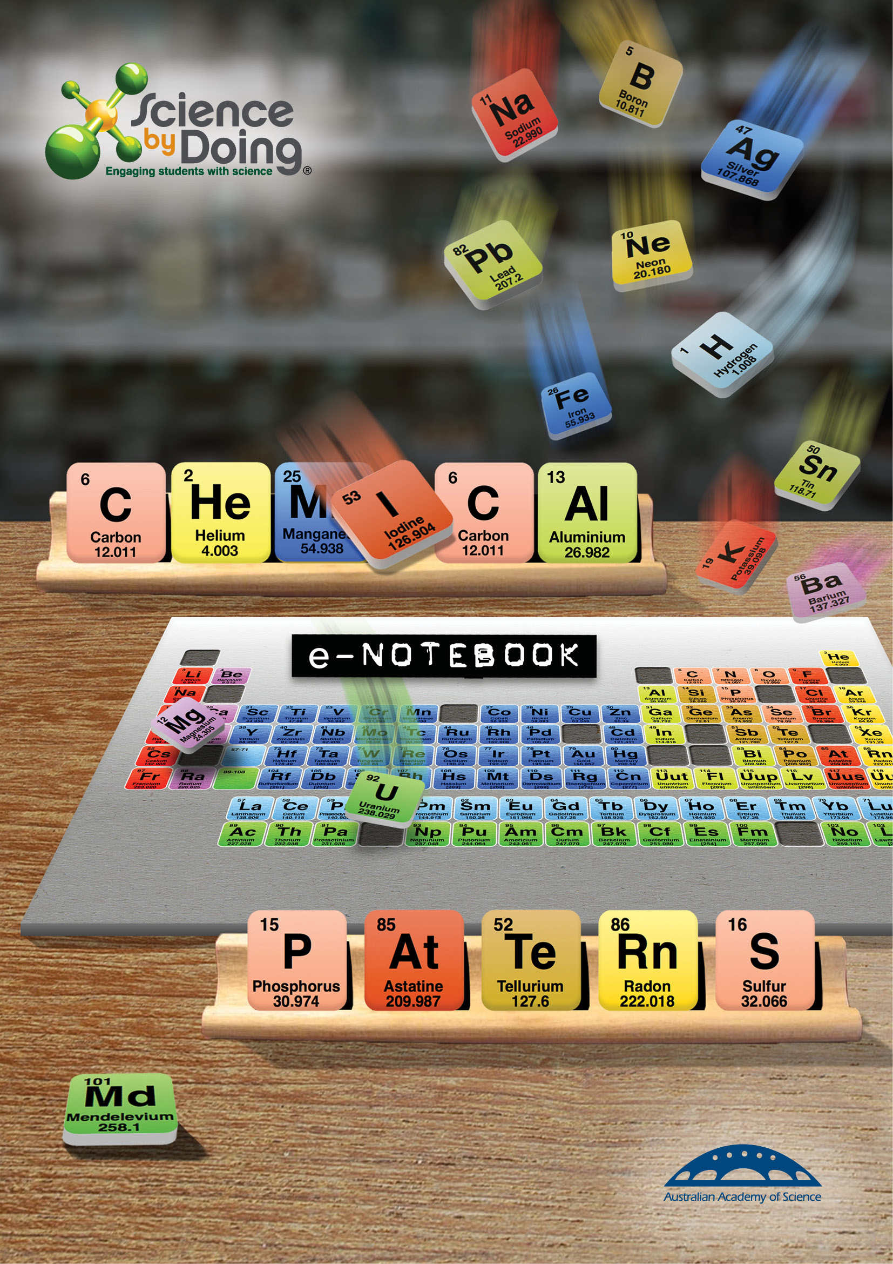

# Activity 2.1 What is a metal?

## Notebook: Comparing transition metals

**What to do:**

Carry out the tests on the transition metals described in the **Student Guide**.

Record your results in **Tables 1** and **2**.

**Table 1: Metal characteristics**

|  |  |  |  |  |  |
| --- | --- | --- | --- | --- | --- |
| **Metal** | **Appearance** | **Reaction with acids** | **Mass (g)** | **Volume (cm3)** | **Density mass/volume (g/cm3)** |
| **iron** |  |  |  |  |  |
| **copper** |  |  |  |  |  |
| **zinc** |  |  |  |  |  |

**Table 2: Reactions involving metal ions**

|  |  |  |  |
| --- | --- | --- | --- |
| **Ions present** | **Fe2+** | **Cu2+** | **Zn2+** |
| **OH-** |  |  |  |
| **CO32-** |  |  |  |
| **Cl-** |  |  |  |

## Discussion

1. Which of the metal samples showed that these metals were:

(i) malleable

|  |
| --- |
|  |

(ii) ductile?

|  |
| --- |
|  |

2. What pattern can you see in the:

(i) density

|  |
| --- |
|  |

(ii) reactivity in acids?

|  |
| --- |
|  |

3. What can you conclude about the reactivity of the ions of the three metals with hydroxides, carbonates and chlorides?

|  |
| --- |
|  |

4. Write equations for any reactions that occurred to form precipitates.

|  |
| --- |
|  |

## Notebook: Unique properties of metals

1. Describe the special nature of metallic bonding.

|  |
| --- |
|  |

2. Explain how metallic bonding accounts for one special property of metals.

|  |
| --- |
|  |

3. Explain what an alloy is.

|  |
| --- |
|  |

4. Describe one property that makes an alloy more useful than pure metals.

|  |
| --- |
|  |

5. Describe one precious metal that is used for a purpose other than jewellery.

|  |
| --- |
|  |

6. What properties of precious metals make them useful?

|  |
| --- |
|  |

7. Watch the bubble raft clip. How does this illustrate the behaviour of atoms found in metals?

|  |
| --- |
|  |

# Activity 2.2 The activity series of metals

**What to do:**

Test each metal in water and acid as described in the **Student Guide**.

|  |  |  |
| --- | --- | --- |
| **METAL** | **REACTION IN WATER** | **REACTION IN ACID** |
| Calcium |  |  |
| Copper |  |  |
| Iron |  |  |
| Lead |  |  |
| Magnesium |  |  |
| Tin |  |  |
| Zinc |  |  |
| Aluminium |  |  |

## Discussion

1. From your results, compare the reactivity of the metals tested.

Explain the evidence that led to your decisions.

|  |
| --- |
|  |

2. Name the gas produced in the reactions and write equations to represent the reactions between:

(i) calcium and water

|  |
| --- |
|  |

(ii) zinc and hydrochloric acid.

|  |
| --- |
|  |

3. List the metals in decreasing order of chemical reactivity. Bracket together any that you think are too hard to separate.

|  |
| --- |
|  |

4. Check your list with the activity series in the *Science by Doing* **Student Digital**. How does it compare? What further tests could you do to confirm the order?

|  |
| --- |
|  |

# Activity 2.3 Metals from ores

**Displacement of metals**

**What to do:**

Carry out the displacement reactions described in the **Student Guide**.

Record your results in the table.

|  |  |  |  |  |
| --- | --- | --- | --- | --- |
| **Metal** | **Copper sulfate** | **Zinc sulfate** | **Magnesium sulfate** | **Iron sulfate** |
| **copper** |  |  |  |  |
| **zinc** |  |  |  |  |
| **magnesium** |  |  |  |  |
| **iron** |  |  |  |  |

## Discussion

1. Which is the most reactive metal? Explain.

|  |
| --- |
|  |

2. The displacement reaction between magnesium and copper sulfate can be represented as:

Mg(s) + Cu2+(aq) 🡪 Mg2+(aq) + Cu(s)

Write similar equations for any other displacement reactions that occur.

|  |
| --- |
|  |

3. List the metals from most to least reactive.

Is the order the same as in the reactions with acids and in the activity series?

|  |
| --- |
|  |

**Copper from copper oxide**

**What to do:**

Carry out the extraction of copper from copper oxide as described in the **Student Guide**.

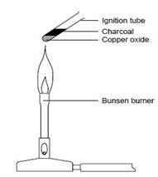

## Discussion

1. There are probably two products produced in this reaction along with the pure copper; both carbon monoxide (CO) and carbon dioxide (CO2).  Write balanced equations describing the formation of these two products.

|  |
| --- |
|  |

2. How does this reaction confirm that carbon sits above copper on the activity series?

|  |
| --- |
|  |

3. Why would it be more difficult to extract iron from iron oxide using this technique?

|  |
| --- |
|  |

**Lead from lead nitrate**

**What to do:**

Place some magnesium into lead nitrate solution as described in the **Student Guide**.

Record your observations:

|  |
| --- |
|  |

## Discussion

1. What has formed on the surface of the magnesium?

|  |
| --- |
|  |

What does this tell you about the reactivity or the two metals involved?

|  |
| --- |
|  |

2. What type of reaction is this?

|  |
| --- |
|  |

Write an equation for the reaction, including all reactants and products.

|  |
| --- |
|  |

## Notebook: Metal extraction

1. Aluminium is more common in the Earth’s crust than iron, but it is more expensive to extract. Explain why.

|  |
| --- |
|  |

2. Why do the types of chemical reactions used to extract iron not work as well for aluminium?

|  |
| --- |
|  |

3. How is carbon monoxide produced for the extraction of iron?

|  |
| --- |
|  |

4. How is carbon monoxide used to remove the oxygen from iron oxides?

|  |
| --- |
|  |

5. What type of chemical process is used to extract aluminium from its ore, bauxite?

|  |
| --- |
|  |

# Activity 2.4 Electrolysis

## Extraction of copper from malachite ore

**What to do:**

Carry out the extraction procedure as described in the **Student Guide**. Record your observations.

|  |
| --- |
|  |

## Discussion

1. In pairs, discuss your observations at each step. Use a flow chart diagram and drawings to illustrate these changes (physical and chemical) for each step.

|  |
| --- |
|  |

2. What did you observe happening to the carbon electrodes before and after a current was applied to the copper solution?

|  |
| --- |
|  |

Summarise the key principles of electrolysis using a diagram and dot points.

|  |
| --- |
|  |

# Activity 2.6 Corrosion

## Comparing corrosion rates

**What to do:**

Set up the corrosion test as described in the **Student Guide**.

|  |
| --- |
|  |

## Discussion:

1. Can you see any differences between the coated and uncoated sides of the metals?

|  |
| --- |
|  |

2. What was the purpose of the varnish?

|  |
| --- |
|  |

3. Rank the metals in order of the amount of corrosion.

|  |
| --- |
|  |

4. Can you explain any differences in the corrosion rate?

|  |
| --- |
|  |

## Corrosion in sea water

**What to do:**

Carry out the corrosion tests in salt water as described in the **Student Guide**.

**Discussion**

1. Did sea water accelerate the rate of rusting of the nail? How could you tell?

|  |
| --- |
|  |

2. Did wrapping the nail with another metal prevent corrosion? Which metal was effective? Can you explain how this happens?

|  |
| --- |
|  |

Write an equation to represent any reaction that occurs.

|  |
| --- |
|  |

3. What might be a problem in using magnesium to protect iron or steel structures?

|  |
| --- |
|  |

4. Was this experiment a fair test?

Explain.

|  |
| --- |
|  |

5. Design an experiment to find out how the concentration of salt solution affects corrosion.

Make sure you consider variables to make this a fair test.

Give it a go!

**My experimental design**

|  |
| --- |
|  |

**Results and conclusions**

|  |
| --- |
|  |

# Activity 2.7 Protecting metals

## Electroplating

**What to do:**

Carry out the process to electroplate a coin as described in the **Student Guide**.

**Results:**

You may include a photograph of the experimental set up and the resulting coin.

|  |
| --- |
|  |

## Discussion

1. What happens at the cathode?

|  |
| --- |
|  |

2. What happens at the anode?

|  |
| --- |
|  |

3. What is the advantage of coating metal objects with other metals?

|  |
| --- |
|  |

4. Write an equation to represent the reaction.

|  |
| --- |
|  |

## Anodising aluminium

**What to do:**

Anodise a piece of aluminium using the procedure described in the **Student Guide.**

Include some photos of the experimental set up and the anodised aluminium.

|  |
| --- |
|  |

## Discussion

1. Describe what is happening at the anode.

|  |
| --- |
|  |

2. What did you observe at the cathode? Can you explain this?

|  |
| --- |
|  |

3. Describe the surface of the anodised aluminium. How well did the dye take?

|  |
| --- |
|  |

## Notebook: Protecting metals

Provide an example of where metals are protected from corrosion using each of the following processes.

1. Protective coatings

|  |
| --- |
|  |

2. Sacrificial anode

|  |
| --- |
|  |

3. Anodising

|  |
| --- |
|  |

4. Galvanising

|  |
| --- |
|  |

**Lesson Outcomes Checklist Part 2**

**NAME:**

|  |  |  |
| --- | --- | --- |
| **ACTIVITY** | **LESSON OUTCOMES**  **At the end of these activities I can:** | **Please indicate if you achieved each learning outcome:**  **✓ = Yes**  **? = Partly**  **X = No** |
| **Activity 2.1 What is a metal?** | * explain the properties of metals in terms of the arrangement of electrons in the crystal lattice |  |
| * describe the distribution of metals in the periodic table |  |
| * investigate the properties of common metals. |  |
| **Activity 2.2 The activity series of metals** | * undertake first-hand laboratory investigations to compare the reactivity of a variety of metals |  |
| * describe the properties of metals in terms of the structure and arrangement of atoms in crystal lattices. |  |
| **Activity 2.3** **Metals from ores** | * investigate the activity of a range of metals to deduce their relative order of reactivity |  |
| * write equations to represent displacement reactions |  |
| * describe the relationship between the reactivity of a metal, its occurrence in nature and how it is extracted from ore. |  |
| **Activity 2.4 Electrolysis** | * safely construct, assemble and manipulate equipment to carry out electrolysis |  |
| * apply my understanding of the periodic table and electricity to explain the process of electrolysis. |  |

|  |  |  |
| --- | --- | --- |
| **ACTIVITY** | **LESSON OUTCOMES**  **At the end of these activities I can:** | **Please indicate if you achieved each learning outcome:**  **✓ = Yes**  **? = Partly**  **X = No** |
| **Activity 2.5 Metals we use** | * describe specific uses of metals linked to their unique properties |  |
| * select and extract data from appropriate digital technologies |  |
| * describe how alloys can enhance the properties of metals. |  |
| **Activity 2.6 Corrosion** | * identify factors that affect the corrosion of metals |  |
| * describe methods of reducing corrosion |  |
| * investigate factors affecting corrosion |  |
| * design a controlled experiment to collect valid first-hand data. |  |
| **Activity 2.7** **Protecting metals** | * anodise and electroplate an object |  |
| * describe how electrolytic processes protect metals |  |
| * evaluate information from secondary sources to consider the future use of metals. |  |